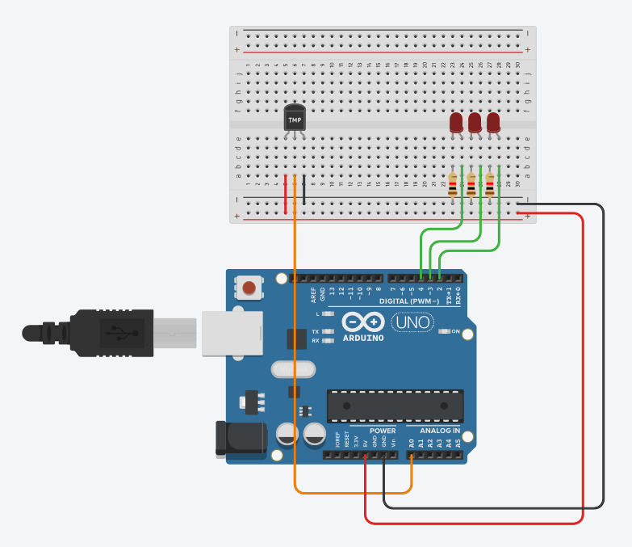
const int sensorPin = A0;
const float baselineTemp = 20.0;

void setup(){
Serial.begin(9600);

for (int pinNumber = 2; pinNumber <5; pinNumber++){
pinMode(pinNumber, OUTPUT);
digitalWrite(pinNumber,LOW);
}
}

void loop(){
int sensorVal = analogRead(sensorPin);
Serial.print("Sensor Value : ");
Serial.print("sensorVal");
float voltage = (sensorVal/1024.0)*5.0;

Serial.print(", Volts:");
Serial.print(voltage);

Serial.print(", degrees C: ");
// convert the voltage to temperature in degrees
float temperature = ((voltage - .5) * 100);
Serial.println(temperature);

if(temperature < baselineTemp){
digitalWrite(2, LOW);
digitalWrite(3, LOW);
digitalWrite(4, LOW);

}else if(temperature >= baselineTemp+2 &&
temperature < baselineTemp+4){
digitalWrite(2, HIGH);
digitalWrite(3, LOW);
digitalWrite(4, LOW);

}else if(temperature >= baselineTemp+4 &&
temperature < baselineTemp+6){
digitalWrite(2, HIGH);
digitalWrite(3, HIGH);
digitalWrite(4, LOW);

}else if(temperature >= baselineTemp+6){
digitalWrite(2, HIGH);
digitalWrite(3, HIGH);
digitalWrite(4, HIGH);

}
delay(1);
}
